

Your Guide To Events and Activities At The Mall for November 2005

SANTA CLAUS IS COMING EVERY WEEKEND IN DECEMBER
Santa Claus will arrive at the Hanmer Valley Shopping Centre on Friday, December 2 from 6 to 8 p.m. He will be spending time in the mall every weekend in December, meeting with all the girls and boys from Valley East and Capreol. Parents are invited to bring along their own cameras this year and take all of the pictures you wish while your children are talking to Santa. Santa will even have a candy cane for all of the kids!

SANTA’S SCHEDULE AT THE MALL
(Every weekend in December)

Fridays: 6 p.m. to 8 p.m.
Saturdays: 10 a.m. to 4 p.m.
Sundays: 12 noon to 4 p.m.

Santa will also be in the mall from Monday, December 19 to 22 from 6 p.m. to 8 p.m. every day during the last week before Christmas. Make sure you come and visit Santa often!

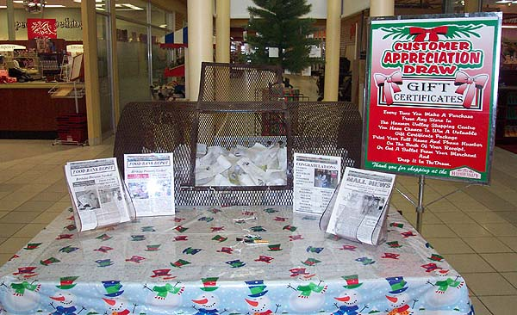
ENTER EVERY TIME YOU COME TO THE MALL FOR THE CUSTOMER APPRECIATION $500 SHOPPING SPREE

All shoppers are reminded to enter the Customer Appreciation Draw and have a chance to win a $500 shopping spree. One lucky winner will be drawn on December 24, 2005. That person will win $500 in cash towards past or future purchases from any store in the mall. Keep your receipts from November and December and you can turn them in for cash. Or you can make purchases any time up to the end of January 2006 and turn the receipts in to receive your $500 prize. As a special Bonus Prize, if the winning ticket contains your email address, you will win a full year of Unlimited Long Distance Phone Calling in Ontario from VCCNet Internet Communications. Enter every time you come to the mall!

.


ELECTRONIC NEWSLETTER

The VALLEY EAST TODAY ELECTRONIC NEWSLETTER is a service being provided to all individuals who would like to be kept informed of the accomplishments, achievements and interests of people living in and around the community of Valley East. Each week registered subscribers will receive an email containing several headlines and summary descriptions of articles of interest that can then be directly accessed from the community web site at WWW.VALLEYEASTTODAY.CA.
Registering to receive your copy of the Electronic Newsletter is simply. All you have to do is fill in a ballot that will be available at the Customer Appreciation tables which will be found between the pillars at the Desjardins’ Food Basics entrance or in the Southeast corner of the mall near Hart Department Store. The ballot will contain a special place for you to write in your email address. Drop the ballot in the big drum and you will be automatically registered for the ELECTRONIC NEWSLETTER, Once you are added to the registration list, you will receive the VALLEY EAST TODAY ELECTRONIC NEWSLETTER once every week and become much more aware of what is going on in your community. There is absolutely no charge for to receive the Electronic Newsletter service you can unsubscribe at any time if you are not completely satisfied. The Electronic Newsletter will not contain any pop-up advertising. It will consist entirely of information that will be of use and of interest to people in and around Valley East.
This is a community service that is being sponsored by the Hanmer Valley Shopping Centre, the Valley East Today Community Web Site and VCCNet Internet Solutions. The first issue will be sent out on Tuesday, November 29, 2005.

Learn About The Latest Internet Technology Trends During Information Clinic Every 2nd Week At The Mall

So much has been happening with respect to internet technology over the past couple of years that it is hard to keep up. You hear about things such as emails, Electronic Newsletters, web sites and even unlimited long distance phone services over internet lines. It can be quite overwhelming to the average citizen who wants to take advantage of these new communication tools, but who may not know where to begin. To help local residents better understand the latest trends in internet technology, the Hanmer Valley Shopping Centre has arranged to hold special Information Clinics every second Saturday, beginning on Saturday, November 5, 2005. The clinic is being conducted by Edgar Lajambe, owner of VCCNet Internet Solutions, a company which is based in Valley East. Additional clinic dates will be November 19 as well as Dec. 3 & 17. The clinic will run from 9:30 a.m. to 5 p.m. For any additional information you can contact Edgar at 670-4039 or www.vccnet.ca

The Mall News is now available online! You can pick up your copy as usual at the mall all month long, or now you can simply log on to www.valleyeasttoday.ca and download your copy which can be viewed in full colour or printed on your own printer. It will also be sent to you via the Electronic Newsletter beginning in December. What’s more, you will also be able to look at back issues that will be stored as archives on the web site. This is all part of our commitment to provide local residents with value-added services that you can only find at the Hanmer Valley Shopping Centre. We feel that it is important for you to be informed so that you can make wise choices, and we are proud to be of service to our shoppers!

BESWICK DENTURE CLINIC OFFERS GOOD ADVICE FOR DENTURE WEARERS WITH DIABETES

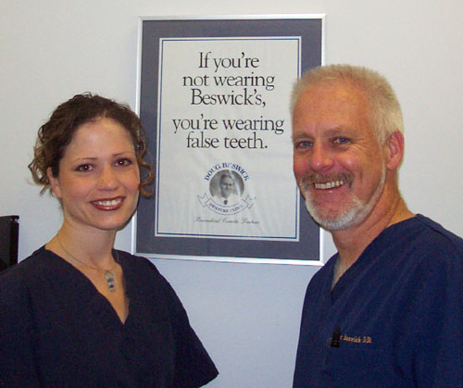

Nicole Brunet, D.D. and Doug Beswick, D.D. spend a great deal of time providing their patients with valuable information which will lead to an improved quality of life. For denture wearers, diabetes creates some special challenges.
Nicole tells us that, “Diabetes is a disease the affects the body in many ways. It can compromise the kidneys, eyes, nerves, heart as well as the mouth. The most common oral implication that is associated with diabetes is gum disease which, if not treated can lead to tooth loss. Other oral problems caused by diabetes are xerostomia ( dry mouth), oral fungal infection (better know as thrush) and poor healing, which in turn can cause additional problems for denture wearers.”
Both Nicole and Doug advise that keeping your mouth healthy is very important if you wear dentures and also have diabetes.
1. Brush and floss your teeth at least twice a day;
2. Keep dentures and partials clean by cleaning them after each meal;
3. Do not smoke. Smoking causes gum disease, dry mouth, and poor healing.
4. If you have dry mouth, drink more fluids. You can also try chewing sugar free gum to help increase saliva flow. It is a good idea to speak to your denturist about alternative treatments for dry mouth;
5. Because an untreated sore spot can lead to further complications such as infections, it is important to get sore spots checked and adjusted immediately by your denturist.
For more information, or to make an appointment to see Nicole or Doug, drop in to the office at the mall or call 969-8086.
MONTHLY CHOLESTEROL CLINIC AT THE MALL | PENNY SALE TABLE  FUND-RAISERS | COMMUNITY USE OF THE MALL IN 2006
Don’t forget to mark your calendar and get your cholesterol and blood pressure checked at our monthly clinic held on the last Friday of every month outside the Valley Plaza Pharmasave Pharmacy. The clinic will be held from 10 a.m. to 2 p.m. | Make sure you check out the web site at www.valleyeasttoday.ca to find out more information about how your group or organization can host a Penny Sale Table at the Hanmer Valley Shopping Centre. Several have already been arranged on weekends in November and December and bookings are now being taken for the new year. This is a fund-raiser that takes very little effort on the part of anyone in the group and has the potential to earn a substantial amount of money during the three days. Call today: 969-7215 | If your group, organization, church or school wishes to book space in the mall during 2006, please contact Robert Kirwan, Director of Marketing & Public Relations for the Hanmer Valley Shopping Centre as soon as possible in order to get your preferred date. There is no charge for community groups to set up public awareness displays or to conduct fund-raisers such as raffles, penny tables, bake sales, etc. Some restrictions do apply with respect to sales of items, so call to discuss your situation: 969-7215.
The Mall News is a publication of
Infocom Canada Business Consultants
It is sponsored by
The Hanmer Valley Shopping Centre
And
www.valleyeasttoday.ca

HANDYMAN PLUMBING CLINIC EVERY SATURDAY MORNING WILL BE WELL APPRECIATED BY ALL DO IT YOURSELFERS

If you have any plumbing projects to do around the house, be sure to drop in to the Hanmer Valley Shopping Centre every Saturday morning between 9 a.m. and 12 noon to get some expert tips from Dave Bateman, owner of CLOGBUSTERS Sewer & Drain Cleaning of Capreol. Dave will be on hand to deal with a different topic every week, but he will also be more than happy to discuss your own specific needs on any topic related to plumbing. The workshop will be held near the entrance to Hanmer Home Hardware. During the month of November, Dave will deal with topics such as How to unclog a sink or small drain (Nov 5); How to replace a faucet (Nov 12); How to solder copper pipes (Nov 19), and; How to fix broken pipes and flooding emergencies (Nov 26). He will also continue into December with other basic topics which will help you around your house. This is a free service being offered to visitors to the mall. If you would like more information from Dave, simply call him at 858-1706.
Dave has found that many people make basic mistakes when working on minor plumbing problems and then they are left with very costly supplementary emergencies. You can find out more by visiting www.clogbusters.com.

Taking Any Family Pictures This Christmas? Find Out What You Should Do To Make Sure Your Photos Turn Out Great!
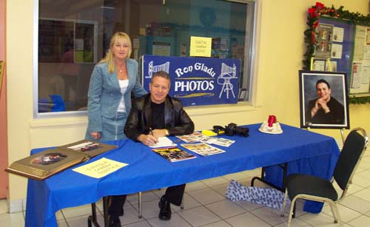
The Hanmer Valley Shopping Centre is pleased to announce the introduction of a monthly photo clinic to our schedule of events. Ron Gladu, of Ron Gladu Photos will be conducting the Information Sessions which will include a wide variety of tips and demonstrations designed to help you get the best results when taking your own personal photos. The first session was held on Saturday, November 12 where Ron provided tips to shoppers about what to look for when buying a camera for personal use. On Saturday, December 17, Ron will once again return between the hours of 10 a.m. and 1:30 p.m. to show you how to take great family pictures during the Christmas holidays. For more information call 969-5018 and speak to Ron or Lise, who is shown in the photo with Ron.

“THIS WEEK AT THE MALL”
Every Wednesday in
The Vision Paper

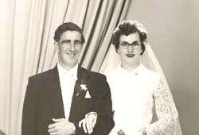
Make sure you check out our weekly column in The Vision Paper, “This Week At The Mall”! You will find it on Page 3, right beside Robert Kirwan’s editorial. “This Week At The Mall” will provide you with up to date information about activities and special events that are taking place at the Hanmer Valley Shopping Centre during the coming week. The mall has become the “unofficial community center” for Valley East as we are more than pleased to do what we can to help schools, churches, and other organizations serve the needs of the communities of Valley East and Capreol. “This Week at the Mall” is a special service to the public and is sponsored by Val & Vi Mazzuca as well as the following merchants of the Hanmer Valley Shopping Centre:
Beswick Denture Clinic | Sole Mates Family Footwear
The Dollar Klub | Dixie Lee Chicken
The Pet Palace | Hanmer Home Hardware
Stan Thomas (Solicitor) | The Source by Circuit City
The Cutting Boutique | The Floral Nook
Drs. Dunlop & Labrecque | Nature’s Apothecary
Lou’s Shoe Repair | Gallery & Brew Shop
G33KTEK Computers | Hart Department Store
Desjardins’ Food Basics | Val & Vi Mazzuca
“WINDOWS IN TIME”
“Windows In Time” is a new “Human Interest Project” that is being initiated to recognize and honour the people who have made a difference in the community of Valley East over the years. The project is being sponsored by the Hanmer Valley Shopping Centre, the Valley East Today community web site, and Ron Gladu Photos. You can find more information on the Community Bulletin board in the East Wing of the mall or by logging on to www.valleyeasttoday.ca. We invite all residents to go through their photo albums and find old photos of themselves or members of their family. Bring the photo to us along with a brief profile telling us how the people in the photo have made a difference in the community or in your own life, and why they should be recognized for their contributions. Keep in mind that we are looking for photos and stories about “ordinary people” who have made this a better community simply by living their lives as responsible, caring citizens. The photo of the happy couple above: Henri-Paul and Jeanette Beaudreau was taken on September 3, 1950.

